**MATLAB/Octave - Plotting Data**

**#plot sin graph**

>> t = [0:0.01:0.98];

>> y1 = sin(2*pi*4*t);

>> plot(t, y1)

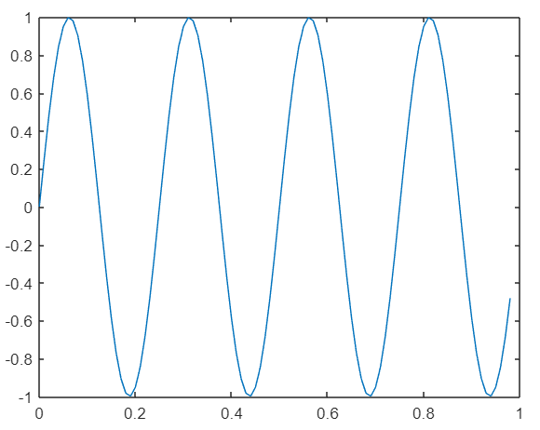

**#plot cos graph**

>> y2 = cos(2*pi*4*t);

>> plot(t, y2)

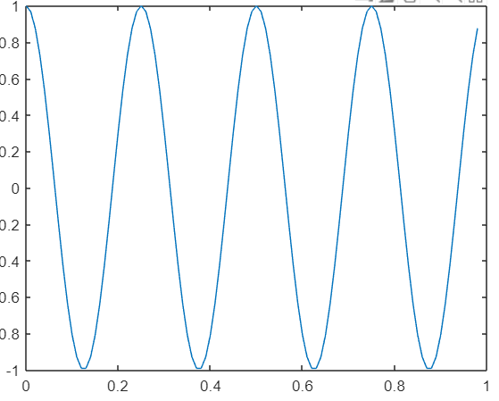

**#plot sin and cos graph one onto another with all labels**

>> plot(t, y1)

>> hold on;

>> plot(t, y2)

>> xlabel('time')

>> ylabel('value')

>> legend('sin', 'cos')

>> title('my plot')

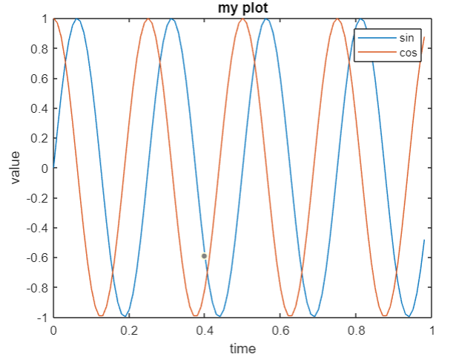

**#plot sin graph with title on the tab**

>> figure(1); plot(t, y1);

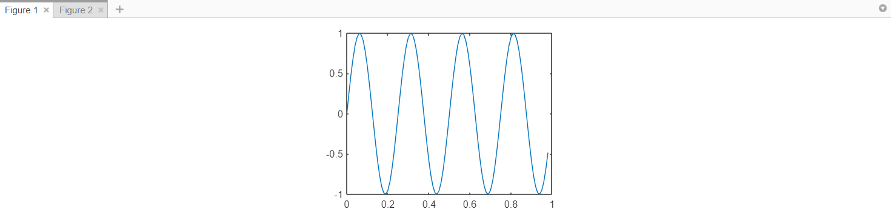

**#plot sin and cos graph one after another in a same row with different axis**

>> subplot(1,2,1);

>> subplot(1,2,1)

>> plot(t, y1)

>> subplot(1,2,2)

>> plot(t, y2)

>> axis([0.5 1 -1 1])

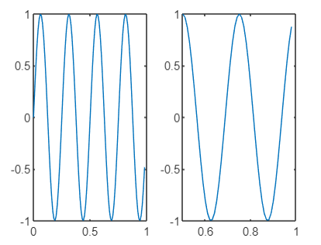

**#clear the frame**

>> clf;

**#visualize the matrix using colorbar scheme**

>> imagesc(magic(15)), colorbar, colormap gray;

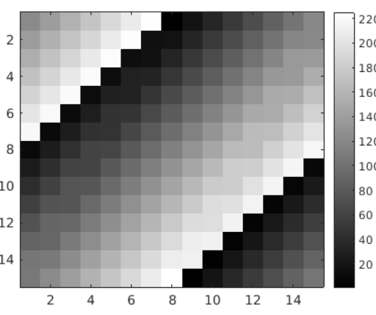

**#run various commands in a single line with values printing onto the console**

>> a=1, b=2, c=3

a =

1

b =

2

c =

3

**#run various commands in a single line without values printing onto the console**

>> a=1; b=2; c=3;